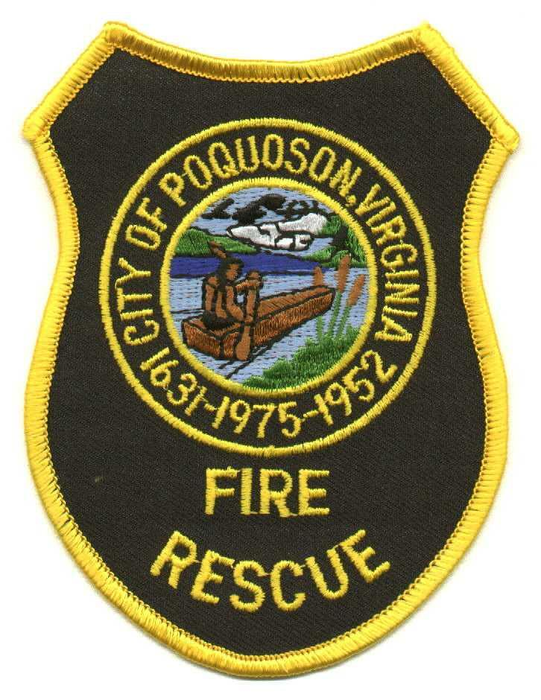

City of Poquoson Fire/Rescue
830 Poquoson Avenue, Poquoson, Virginia 23662 (757) 868-3510 Fax (757) 868-3514

Summary

- This is replacing/updating the original EO 2.00 Emergency Operations in Atmosphere Immediately Dangerous to Life and Health

- Due to the serious nature of MAYDAY and rapid response for a lost/trapped/downed Firefighter, a regional policy has been drafted in conjunction with York, Poquoson, Williamsburg, and James City County. Ensuring we perform in the same fashion as our mutual aid partners is very important when it comes to the safety of our staff.

- Policy now defines the differences between a Rapid Intervention Team (RIT) and an Initial Rapid Intervention Team (IRIT).

- Policy defines safety parameters when operating in a dangerous atmosphere (such as never working alone).

- Policy defines how to declare a MAYDAY.

- Policy lists the only exceptions to entering a dangerous atmosphere without having a safety team available.

- Policy dictates that a Second Alarm will be requested if RIT or MAYDAY is activated.

